**MCOMD1MCS – Mathematics for Computing**

**Assignment 1**

**Lecturer – Cheryl Periton**

**Student – Nathan Shuttleworth**

**Year – 2019/2020**

**Hand in – 11/11/2019**

Task 1:

Slide 1



Slide 2



Fueling in F1 has been banned since 2010. Now, all cars need to have the right amount of fuel at the start of the race to be able to finish and be able to push to overtake in the race, but not have so much that it is too heavy and affect lap times. The current limit is 105 kgs of fuel.

In the equation- M = mass of fuel, E = amount of time added per lap by each kg of fuel, C = fuel consumption per lap.

Slide 3



Whilst wind tunnels are used to test airflow of car prototypes, when being designed digitally software is used to show air flow.

In the formula, Cd = coefficient of drag, A = area being hit by the air, V = velocity of car and F = force of drag.

Designers of the car must achieve the correct balance between keeping the car light and free of drag, but also ensure that there is enough downforce on he car so that it stays on the track at high speeds. That is why this formula is so important.

Slide 4



DRS works by having the back wing fold away to decrease aerodynamic drag. Whilst the wing is usually needed for downforce, particularly when cornering, it is not needed for if the car is in the slipstream of the car in front. If used outside of dedicated DRS zones and when close enough to the car, a penalty can be given. Also if it is used in the wrong place, it will affect the balance of the car and could cause it to spin or crash.

Slide 5



Race pace is often decided by the car leading the race, however once the race reaches the end and more cars have been lapped, this is not always true.

A cars pace is calculated by subtracting the time for the current sector with the last time for the same sector in the last lap. There is a system used to easily understand how the car is improving as the laps go on:

Yellow sector time – no improvement on previous times in that sector

Green sector time – Personal best sector time

Purple sector time – Best out of all drivers in that sector.

Lap times have recently become even more important with the introduction of a bonus point for the car that does the fastest lap.

With the suvat equations, it is important to know the difference between velocity and speed. The total displacement for an F1 car over lap will be zero since they always return to the same place, but when comparing the distance between another car and its velocity relative to them it is more relevant.

Most of this calulation is now done digitally by computers on board the car, but the basis is still the suvat equations.

Task 2:

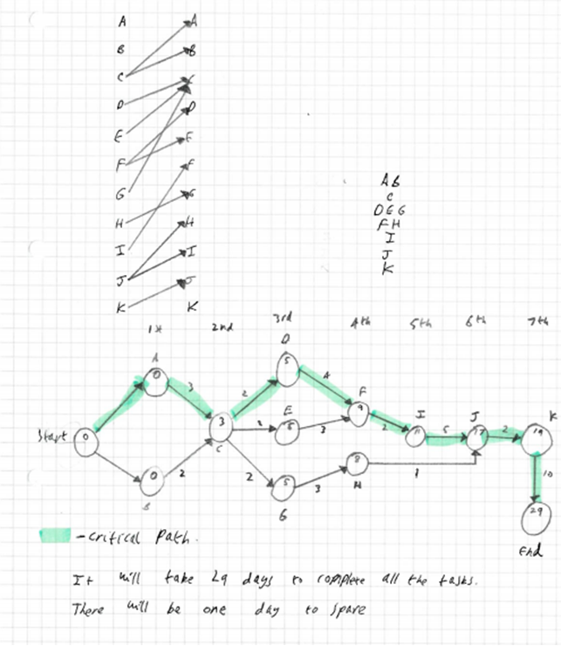

It will take 28 days to complete all the tasks.

There will be one day to spare.

The managers could save time by not spending as long to prepare the artwork, this could have been started on earlier by having some generic artwork that can be used every time they have a sale. This could shorten the critical path by having task E be part of the critical path instead.

Task 3:

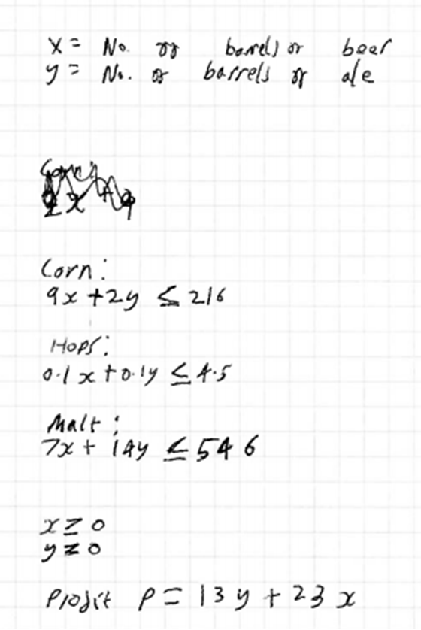

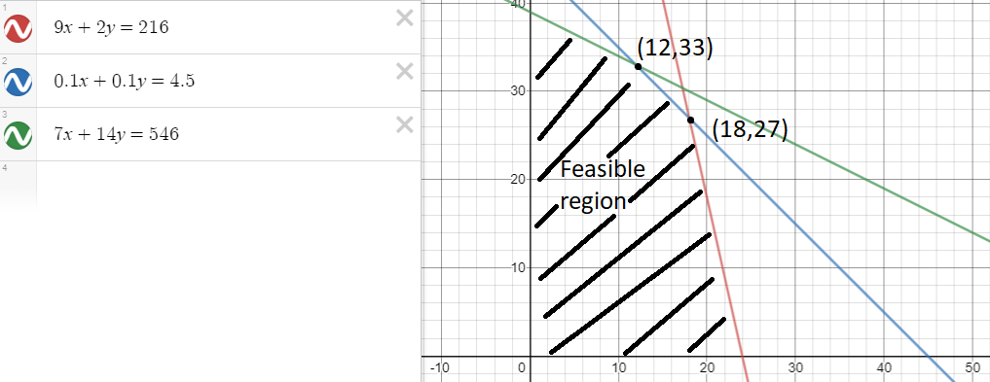

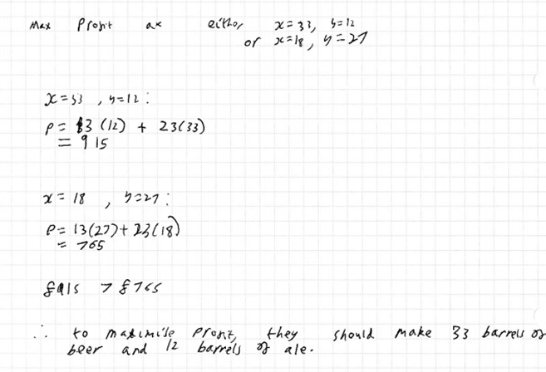

Task 4:

a) I want to be able to cross town from my house to the train station in the fastest time, so as not to miss my train. The times taken to travel down the streets to various landmarks in the town in minutes are detailed below:

|  |  |  |  |  |  |  |  |
| --- | --- | --- | --- | --- | --- | --- | --- |
|  | Home | Bus stop | School | Shop | Park | Library | Train station |
| Home |  | 5 | 8 |  |  | 3 |  |
| Bus stop | 5 |  | 3 | 8 |  |  |  |
| School | 8 | 3 |  |  |  |  |  |
| Shop |  | 8 |  |  |  | 11 | 4 |
| Park |  |  |  |  |  | 9 | 2 |
| Library | 3 |  |  | 11 | 9 |  |  |
| Train station |  |  |  | 4 | 2 |  |  |

None of the streets are one way, you can go either way down them. What route should I take to give the shortest travel time, and how long will it take me?

b)

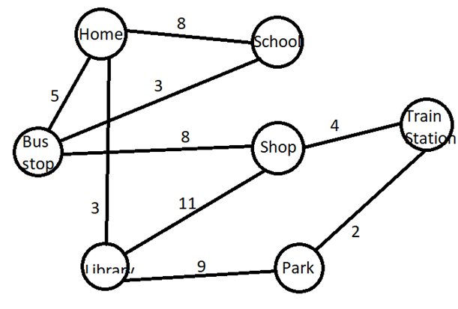

The vertices represent the landmarks in the town, the edges are the streets between them. The weights of the edges show the amount of time it takes to travel down the streets.

c)

Use Dijkstra’s shortest path algorithm to find the shortest path between the nodes labelled home and train station. State the path and the total time taken to travel this path.

d)

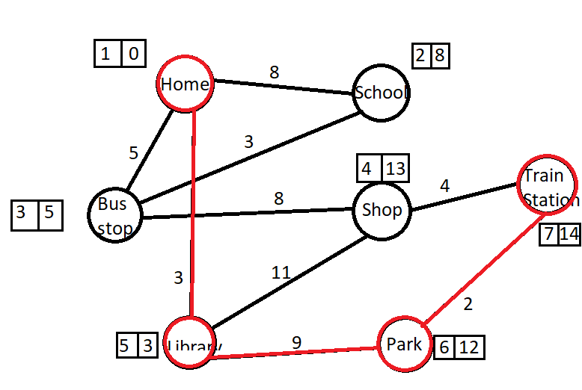

The red path is the shortest one. This was found using Dijkstra's algorithm. In the boxes, the number on the left is the order in which they were labelled, and the right hand number is the shortest weight to be able to reach that node from the start node, home. The path is: Home, library, park, train station. It has a total weight of 14.

e) The shortest route from home to the train station is : Home, library, park, train station. It will take 14 minutes to make the whole journey.